# University of St Andrews Impact & Innovation Fund 2024/25

### Guidance Notes for Applicants

The Impact and Innovation Fund is an internally managed source which is designed to support research impact and innovation. This document provides guidance for the application process, conditions of the fund, eligibility and the quality criteria which are used to assess applications.

‘Impact’ refers to work that uses research to make a beneficial change beyond academia. ‘Innovation’ refers to early-stage commercialisation.

Please note there are different thresholds of funding for the two streams, reflecting the nature of the work to be undertaken.

The aims of the IIF are:

* To seed and strengthen research impact via project funding and PhD internships.
* To nurture engagement with external stakeholders/beneficiaries toward demonstrable change.
* To develop innovation-based work to more advanced TRLs/commercialisation (for those who are outside of our IAA portfolio remits).

### IIF Overview

* The Fund is open to University of St Andrews academic staff. They must have a contract of employment in place that covers the full duration of the project.
* A staff member can be principal investigator on just one application per round.
* Proposals must be based on research conducted (solely or jointly) at the University of St Andrews.
* The Fund is intended to seed nascent impact projects. Applicants are not limited in the number of times they can apply to the scheme. However, it is expected that established projects will seek alternate external funding opportunities.
* The Fund prioritises proposals not eligible for or covered by UKRI Impact Accelerator Accounts held by St Andrews (currently BBSRC, EPSRC and MRC) or similar sources of funding. Proposals that are eligible for other competitive funds with a deadline within 6 months of the IIF deadline will be sent to those competitions instead.
* Upper limits are not guaranteed, and levels of funding are at the discretion of the peer review panel.
* If you have previous IIF or KEI funding, please note you must be up to date with project reports and Pure updates for that funding to be eligible for any additional round.
* If your funding is ongoing, you must explain how your current funding request fits with the previously funded project in your application form.
* External & internal matched funding, in cash or in-kind, should be sought where possible. This includes any funding from the School or Department. This is a desirable criterion only.
* Proposed applications (a) should be reviewed in advance with the School’s Director of Impact & Innovation (DoII), (b) must have the support of the School/Department, and (c) must be submitted with a specific (rather than general) statement of support from the DoII.
* When a School submits multiple applications, the School’s DoII is required to rank them in order of priority to the School. The DoII will submit this ranking to the panel in the week after the competition submission deadline has passed.
* Eligible applications are judged on quality. They are not required to focus on supporting the REF2029 submission. The full scoring criteria are given at the bottom of this document.
* A mandatory Expression of Interest (EoI) stage is expected at least **6 weeks before** the deadline to assess eligibility, resource needs and project development.

### Upcoming Deadlines:

**Main and Small award - 7th October 2024 & 14th April 2025 (Small Fund only - 27th January 2025)**

Impact - Main award: £5,000 to 15,000 Small award: Up to £5,000

Innovation - Main award: £7,500 to £25,000 Small award: Up to £7,500

Rapid Response Projects

* If there is a demonstrable urgent need, Impact & Innovation Fund applications will be considered out-of-sequence in an expedited manner.
* These proposals can request up to £2,500.
* Rapid Response projects have a maximum duration of 3 months from the start date specified in your proposal. They cannot be extended.
* Rapid Response applications will be considered on their individual merit using the criteria for selection. Please note that the IIF conditions of funding will apply.
* [Please complete the QUALTRICS Rapid Response form](https://standrews.eu.qualtrics.com/jfe/form/SV_7VvwiwAtWFJm5Cu)

### Examples of Impact:

#### IIF projects have previously generated change in the following areas:

* Policy change/influence at the Scottish, UK and International level
* Deepening public understanding
* Change of practice through curricula, creative industries, heritage sector etc
* Inclusive change by championing marginalised people and perspectives
* Influencing methods
* Contributing to economic growth
* Regional development in the UK and internationally

### All activity must be underpinned by research undertaken at University of St Andrews, target a specific audience and be intended to create evidencable change

### Examples of activities[1]:

#### Impact stream awards can be used for:

* Events, exhibits, websites which engage with specific non-academic audiences
* Public engagement with specific target audiences can be funded if it is an activity which is based on research conducted at the University of St Andrews and could lead to demonstrable changes or benefits to the target audience(s).
* Engaging with and seeking to change the lives of vulnerable populations e.g. children (subject to [ethical approval](https://www.st-andrews.ac.uk/research/integrity-ethics/humans/) and appropriate clearance)
* Workshops, conferences or networking events specifically targeted at working with external organisations and non-academic users of research.
* Provision of training or expertise which will benefit practitioners or other non-academics.
* Practical applications of research to improve the environment, reduce pollution, recycle waste products, or improve sustainability, health, quality of life, understanding of health issues, deliver new treatments or therapies, affect non-academic practice or guidelines, etc.
* Engagement with intermediary groups, such as NGOs, policy makers or local government, which will influence subsequent policy and practice.

#### Innovation stream awards can be used to:

* Strengthen user engagement.
* Strengthen the exchange of knowledge through culture change and capability development, including through the development of skills.
* Support knowledge exchange and commercialisation at early stages of progressing research outputs and outcomes to the point when they would be supported by other funding.
* Support new, innovative and imaginative approaches to knowledge exchange and Impact, including processes that enable ‘fast fail’ and appropriate learning.
* Support activities that enable impact to be achieved in an effective and timely manner including secondments and people exchange.
* For commercialisation of research, we would expect to fund in Technology Readiness Levels (TRL) 3 to 6.

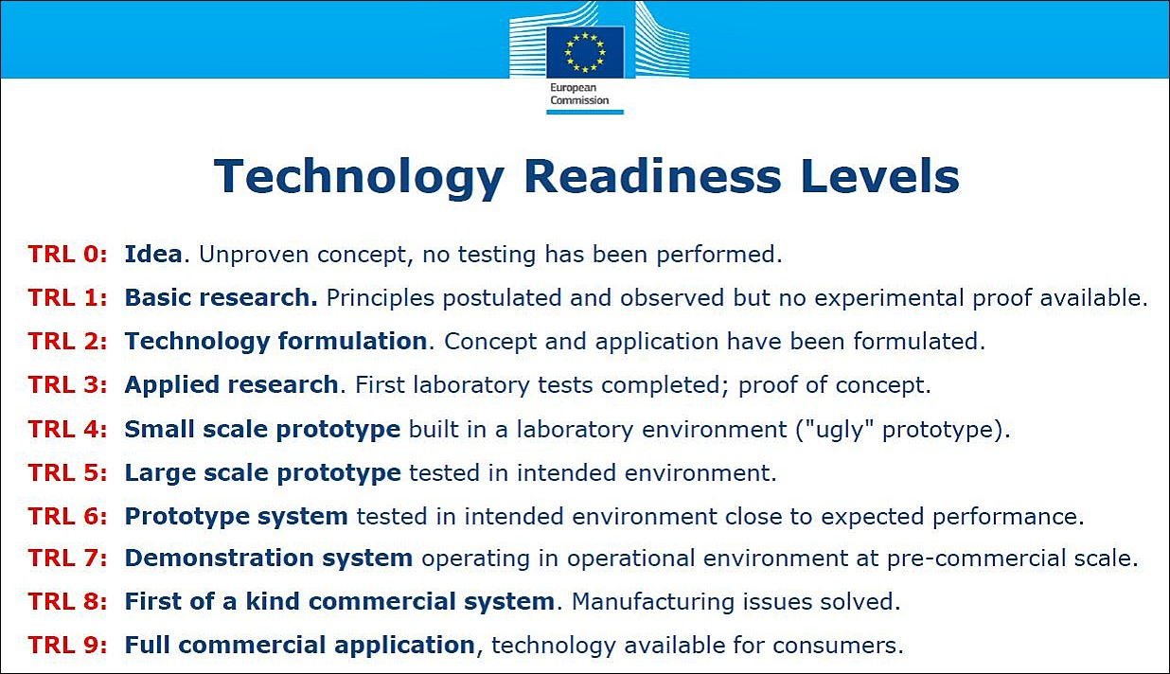

### Allowable costs:

* Travel costs can be included if they are part of the mechanisms to achieve impact, e.g. meetings with non-academic partners.
* The purchase of equipment is allowable if this is an essential part of the proposal to create impact.
* Non-permanent staff time.

The following costs and activities cannot be funded:

* Research projects (e.g., activities that could normally be funded through research grants)
* Salary costs for permanent members of staff.
* Activities where the focus or target audience is primarily academic.
* Costs associated with the protection of intellectual property.
* Public-engagement activities that are non-specific or that do not involve a two-way knowledge exchange (e.g., a television broadcast would not be funded).
* Conference attendance (except where the project is using the attendance to deliver a strategic, targeted intervention that will generate impact by, for example, strengthening a collaborative relationship with a non-academic partner organisation.)
* The purchase of – or contribution toward – a single item of equipment costing £10,000 or greater.
* Indirect or estates costs.

### Staff costings

Awards will be made following approval by the committee and subject to FAS confirmation of costs (minor discrepancies are expected due to inflation and travel restrictions, for example).

## For 2024/25, we request that applicants use the supplied average salary costing table below.

|  |  |  |
| --- | --- | --- |
| Grade | Est. Total Annual Salary 2024/25 | Est. Total Monthly Salary 2024/25 |
| Grade 4 (e.g. Administrative Staff) | £34,550 | £2,879 |
| Grade 5 (e.g. Technicians) | £42,192 | £3,516 |
| Grade 6 (e.g. Research Assistant) | £50,733 | £4,227 |
| Grade 7 (e.g. Academic) | £64,541 | £5,378 |

### Funding compliance

Any submitted application must agree to the following:

## You must follow the [University's rules for the employment of staff](https://www.st-andrews.ac.uk/hr/supportandadvice/).

## You should discuss new research posts with the Higher Education Role Analysis (HERA) team to [establish the correct grading](https://www.st-andrews.ac.uk/hr/gradingrewardandconditions/roleanalysisheraoverview/) before submitting a grant application.

## Projects must comply with appropriate [ethical procedures](https://www.st-andrews.ac.uk/research/integrity-ethics/), including Trusted Research.

* If buying goods or services from outside the UK, please read the following [guidance](https://www.st-andrews.ac.uk/staff/money/vatguidelines/buyinggoodsandservicesfromoverseas/).

### Conditions of funding:

* Funded projects will typically last 1-12 months. The grant spend **must be completed within 15 months of the funding decision.** If there is any change to the expected timings or scope of the project, the staff member must contact the Research Impact team as soon as possible.
* A record of any activities and impacts which result from the award must be entered [in PURE](https://impact.wp.st-andrews.ac.uk/recording-impact-in-pure/). If there is no information related to the project in PURE when funding is awarded, the Research Impact team will open a new impact entry and add the application form.
* Pure should be populated by the researcher(s) involved with information on any events and evidence of impacts as the project progresses.
* Final project reports will be required upon completion of the project (the Research Impact team will provide a proforma) and PURE entries must be up to date by the end of the grant and no later than 15 months after the funding start date.
* You may be requested to showcase projects and outcomes in different formats (online, case studies, events etc.).

# Criteria for selection

Applications which are eligible will progress to a peer-review panel scoring and review process. The panel will score based on the essential/desirable criteria. Requests for clarification can also be made to applicants at any point in the process. If you have questions on the criteria, please contact the [Research Impact team](mailto:impact@st-andrews.ac.uk).

### Eligibility:

* Proposals must focus on impact (not basic research, not dissemination of basic research).
* The impact stems from research outputs, wholly or in part, from the University of St Andrews. Upcoming publications/outputs also meet this criterion.
* Proposals must provide letters of support for all external partnerships they name.
* There are clear proposed timescales for completion of activities including milestones and designated ‘fast fail’ points. (‘Fast fail’ points are instances where the project is unable to succeed as first planned and will use its progress to agree an altered scope with the panel chair, through the Research Impact team, or will cease its work.)
* Proposals must address the principles of responsible innovation and the AREA (Anticipate, Reflect, Engage, Act) framework. (Please consult [this resource](https://impact.wp.st-andrews.ac.uk/responsible-research-and-innovation-area/) for more information).

**Projects that do not meet the eligibility criteria will be rejected without going to the Panel.**

### Research Excellence Framework (REF) Information

The review panel may choose to prioritise proposals that support a School’s identified REF Impact Case Study submission. This will be dependent on strategic need and is at the discretion of the panel and Chair.

Innovation Stream Additional Eligibility Information:

* The Technology Transfer Centre will decide if proposals are eligible for the Innovation Stream.
* Innovation proposals must be based on a technology that can generate commercial income.
* The technology must have been previously disclosed to and assessed by the [Technology Transfer Centre](https://www.st-andrews.ac.uk/research/support/technology-transfer/) (TTC). The proposal must include the Technology ID number provided by TTC (e.g. 23-T00123). TTC will only provide a statement of support for proposals for previously disclosed technologies; please approach the TTC team at least 2 weeks before the application deadline.

### Quality Indicators

These indicators form the metrics used to assess applications. A sample scoresheet is available [online](https://impact.wp.st-andrews.ac.uk/impact-and-innovation-fund-2024-2025/):

#### Essential:

* High likelihood the project will [generate impact](https://impact.wp.st-andrews.ac.uk/embedding-impact/) via:
  + Reach – the breadth of target beneficiaries has been maximised.
  + Significance – the permeation of the impact has been maximised.
* Evidence of engagement with appropriate external partners.
* Appropriate [mechanisms](https://impact.wp.st-andrews.ac.uk/qualitative-and-quantitative-impact/) to capture evidence of impact.
* Inclusion of next steps/forward thinking following the funding period
* Clear [project planning](https://impact.wp.st-andrews.ac.uk/impact-timescales/) including costings, timescales.
* For Innovation projects: The proposal must have commercialisation potential which has been disclosed to TTC.

#### Desirable:

* External and/or internal matched funding, in cash or in-kind, including any funding from the School/Department.
* Involves a sustainable relationship with beneficiaries.
* Further opportunity to gain additional funding from external partners.
* Raises the reputation of University of St Andrews outside of the institution.
* Contributes to strategic initiatives, e.g., [University strategy](https://www.st-andrews.ac.uk/about/governance/university-strategy/), [REF2029](https://www.ref.ac.uk/), etc.

**The Panel will use ‘Desirable’ criteria to distinguish between proposals considered to score equally in ‘Essential’ criteria. All applications will receive feedback from both the review panel and the Research Impact team. All applicants will be offered project development support through the Research Impact team, with collaboration from DoIIs, RIS, TTC etc as appropriate.**

**If you have any questions about the IIF process, this guidance, or your potential application, please** [**contact the Research Impact team**](mailto:impact@st-andrews.ac.uk)**.**

1. This is a non-exhaustive list of project types and any research-based projects which are aimed at the creation of impact will be considered.