University of St Andrews BBSRC “Explorer” Impact Acceleration Account (IAA) 2023-24

Guidance Notes for Applicants

Impact Acceleration Accounts (IAAs) are strategic awards provided to research organisations to allow them to respond to impact opportunities in more flexible, responsive and creative ways. The awards are intended to nurture impact journeys and take advantage of new or unforeseen opportunities to facilitate the realisation of impact. The funding can be used to support a wide range of activities that support the scheme’s aims, including engaging users, forging strategic partnerships or progressing commercial opportunities.
UKRI have removed the requirement that all IAA-funded projects be directly related to previous UKRI funding; however, they still require funded projects to sit predominantly within the remit and aims of the BBSRC. Therefore, any project supported by the BBSRC “Explorer” IAA should be at least 50% within the BBSRC remit.

Background of harmonisation of IAAs
UKRI has brought together IAA funding from 5 participating councils (AHRC, BBSRC, EPSRC, MRC and the STFC) and harmonised Higher Education Institution (HEI) block applications for these as well as the award timelines and processes. Where applicable and appropriate, UKRI has encouraged research organisations to take advantage of the strategic opportunities afforded by the alignment of IAA awards across disciplines. However, it is recognised that opportunities for alignment may not always be obvious or accessible. Therefore, single discipline applications have not been disadvantaged.

UKRI IAA strategic aims are:
- to strengthen engagement with users to accelerate the translation of research outputs into impacts;
- to support, develop and foster strategic partnerships for knowledge exchange and impact, including across disciplines and sectors;
- to build and maintain an environment and culture which enables effective and ambitious knowledge exchange and impact, including the development of skills, capacity, and capability within research organisations;
- to provide early-stage support for progressing research outputs towards the next stages in the impact pipeline, for example, proof of concept projects, commercialisation, market validation, or activities targeting policy, business and the third sectors;
- to drive continuous improvement in impact by supporting innovation, enabling “fast failure”, and capturing learning through appropriate mechanisms; and
- to empower institutions with flexible and adaptive approaches to knowledge exchange and impact, including the ability to respond quickly to emerging opportunities.

St Andrews BBSRC “Explorer” IAA
The “Explorer” fund is designed for PIs who have not previously been funded through BBSRC IAA funding or those planning to apply for BBSRC Follow-on funding (https://www.ukri.org/opportunity/bbsrc-follow-on-funding/).
All projects will undertake one or more of the following activities:
- market validation
- proof-of-concept projects
- engagement with users and/or industry partners
This funding stream is for projects up to £15k and with a spend deadline of 31st March 2024.
Where interdisciplinary projects work across MRC and EPSRC remits, we will work with the panels of those Harmonised IAAs, as appropriate.

Eligibility criteria:
- The BBSRC “Explorer” IAA fund is open to the University of St Andrews academic staff, including both research only and research & teaching staff on fixed or permanent contracts. We actively encourage applications from early career and under-represented researchers.
- Projects’ underpinning research must fall within the BBSRC-remit.
- Interdisciplinary projects delivering impact or translational activities across discipline and faculty boundaries, i.e. across research council remit boundaries, are actively sought. Please note that such projects should be at least 50% within the BBSRC remit and should be submitted by the BBSRC remit academic.
- It is recognised that successful awards could lead to subsequent proposals to other internal funds in future.

Deadline for proposals: 12 Noon, 8th September 2023
- Proposal applications (a) should be reviewed in advance with the relevant Director of Impact & Innovation (DOII), (b) must have the support of the relevant Schools/Departments, and (c) must be submitted with a specific (rather than general) statement of support from the submitting School/Department’s DOII.
- For external partnerships, please provide letters of support where applicable.
- Innovation proposals must be based on a technology previously disclosed and assessed by the Technology Transfer Centre (TTC) and include the Technology ID number provided by TTC (e.g. 23-T00123). TTC will only provide a statement of support for proposals for previously disclosed technologies; please approach the TTC team at least 2 weeks before the application deadline.
- Proposal applications will be assessed by an interdisciplinary Review Panel, made up of members of the BBSRC IAA Steering Group.
- Decisions will typically be communicated within 3-4 weeks of the proposal deadlines.

The objective of this funding is to increase the impact of BBSRC-remit research by:
- Strengthening non-academic user engagement
- Supporting Knowledge Exchange (KE) and commercialisation in the early stages by progressing research outputs/outcomes to the point where they would be supported by other funding
- Strengthening KE and commercialisation through culture and capability development
The Principal Investigator applying for BBSRC IAA funding should be from an BBSRC-remit discipline or be conducting BBSRC-remit research. Projects must sit within the remit and aims of the UKRI and, for this funding opportunity, must sit predominantly within the remit and aims of the BBSRC. Therefore, any project supported by the BBSRC IAA should be, at minimum, 50% within the BBSRC-remit.

What can I apply for?
Eligible costs include any activities or mechanisms to achieve impact, such as:
- Travel and subsistence, consumables
- Researcher/PDRA salaries
- Specialist advice and market research
- Meetings, workshops, conferences, and networking events specifically targeted at external organisations and non-academic users of research.
- Provision of training or expertise which will benefit practitioners or other non-academics.
- Practical applications of research to improve the environment, reduce pollution, recycle waste products, or improve sustainability, health, quality of life, understanding of health issues, deliver new treatments or therapies, affect non-academic practice or guidelines, etc.
- Engagement with intermediary groups, such as NGOs, policymakers or local government which will influence subsequent policy and practice.

Ineligible costs:
- Costs related to basic research activity, which should be funded through standard grant route
- Costs that should have been anticipated and supported as part of the initial funding (such as public engagement related to a specific grant)
- Undergraduate activities, core PhD, Masters and CPD costs or training
- Equipment with a value over £10,000 per item
- Indirect costs or estate costs
- Late-stage commercial development for which there are other funding sources, e.g. companies, Innovate UK, Venture Capital, Scottish Enterprise, etc.

Staff costings
Awards will be made following approval by the committee and subject to FAS confirmation of costs (minor discrepancies are expected due to inflation and travel restrictions, for example).

For 2023/24, we request that applicants use Worktribe to obtain accurate staff salary costs. To see more information please visit https://www.st-andrews.ac.uk/researchfundingsupport/applyingforfunding/.
Worktribe calculates staffing costs for existing or unnamed staff members. It is the responsibility of the applicant to obtain these costs before putting into the application.
Staffing costs are often the largest component of a grant. You must follow the University's rules for the employment of staff.
You should discuss new research posts with the Higher Education Role Analysis (HERA) team to establish the correct grading before submitting a grant application.

Support for costings
Finance Advice and Support (FAS) will act as the first point of support. Please submit any queries to your regular FAS contact.
You can also contact FAS within Worktribe by using the @ function.

Impact types and indicators
Please refer to our Evidence for Impact Types and Case Study Examples resource or the REF2021, Panel Criteria and Working Methods, Annex A (https://impact.wp.st-andrews.ac.uk/files/2022/01/Annex-A-Impacts-and-Indicators.docx) and Research Impact Evidence. The application also asks which UN Sustainable Development Goals (SDGs) are being addressed in the project. Information on SDGs can be accessed here: https://www.un.org/sustainabledevelopment/sustainable-development-goals/

Innovation proposals
Innovation proposals should be directed towards activities that support commercialisation such as proof of concept, development of prototypes, scale-up, market research, customer discovery, etc.
For Innovation proposals with commercialisation potential, we would expect to fund in Technology Readiness Levels (TRL) 3 to 6.
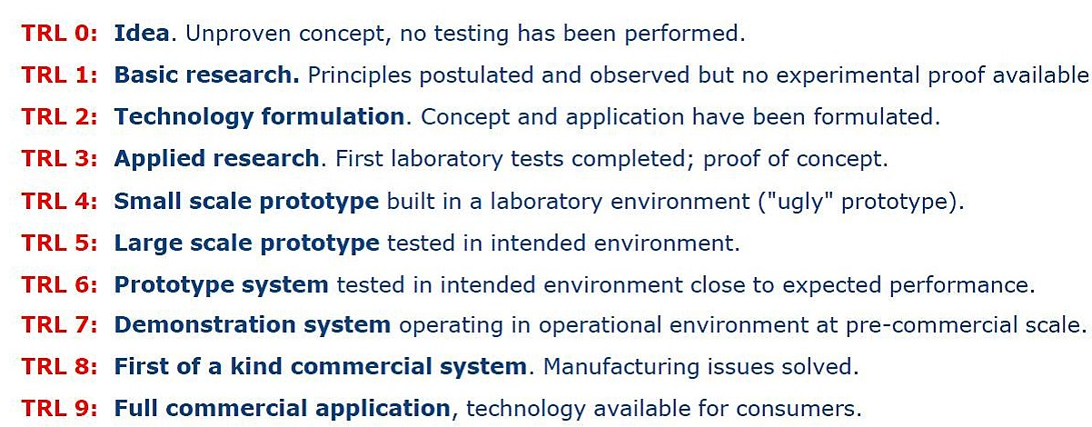
We encourage all BBSRC “Explorer” IAA funded individuals to work closely with the St Andrews Innovation team (https://innovation.st-andrews.ac.uk/) throughout their projects in order to maximise the likelihood of future potential for innovation.

Conflict of interest
Applicants are requested to read the Declaration of Interests policy (https://www.st-andrews.ac.uk/policy/research-external-work/declaration-of-interests-policy.pdf) and to declare any potential, real or perceived conflicts of interest with their proposed application.

Conditions of funding
- For each project, PIs will attend a mid-project review with select panel members, key stakeholders (where appropriate) and/or relevant support unit representatives.
- All project work and spend are to be completed by 31 March 2024.
- If there is any change to the expected timings or scope of the project, the staff member must contact the Impact Team as soon as possible.
- A record of any activities and impacts which result from the award must be entered in Pure. If there is no information related to the project in Pure when funding is awarded, the Impact Team will open a new impact record and add the application form.
- Pure should be populated by the researcher(s) involved with information on any events and evidence of impacts as the project progresses.
- Final project reports will be required upon completion of the project (the Impact Team will provide a proforma), and Pure entries must be up to date by the end of the grant and no later than 15 months after the funding start date.
- Where applicable, successful proposals are subject to ethical approval.
- Participation at events to showcase the projects and outcomes may be requested.

Criteria for selection

Essential:
- Applicant must either be new to internal BBSRC IAA funding or be planning apply for BBSRC Follow-on funding (https://www.ukri.org/opportunity/bbsrc-follow-on-funding/)
- All projects will undertake one or more of the following activities:
- market validation
- proof-of-concept projects
- engagement with users and/or industry partners
- Clear and measurable milestones with a clear pathway to reach intended impact targets/objectives
- Clarity and realistic plans to generate change or benefit in the long term
- Clear and realistic plans for capturing evidence of activities and changes as they arise (See: REF2021 Annex A: https://impact.wp.st-andrews.ac.uk/files/2022/01/Annex-A-Impacts-and-Indicators.docx)
- Clearly and adequately addressed principles of responsible innovation (https://www.ukri.org/about-us/policies-standards-and-data/good-research-resource-hub/responsible-innovation/) and AREA (https://epsrc.ukri.org/index.cfm/research/framework/) – Please reflect on positive and potential unintended consequences and ensure specific corresponding actions are included in the application.
- Foundation of good quality research conducted, wholly or in part, at the University of St Andrews, which will link to any resulting impact
- Clarity on the planned or intended non-academic target audience(s) or partners
- Clear and realistic plans to engage with external partners, beneficiaries and stakeholders, where applicable
- Clear and realistic plans for capturing evidence of activities or impacts as they arise
- Appropriate levels of costing in support of the application
- Stream 1 (Main awards) must have established partnerships leading to impact with LoS from current partners.
- Applications which have been favourably reviewed by other panels and advised to apply to an IAA by the Research Impact team, may be eligible for Stream 1, if advised as such by the Research Impact Team, under this criterion.

Desirable:
- High quality and/or innovative approach to engagement with users of research
- Delivering impact or translational activities across discipline boundaries through interdisciplinary means
- Long-term development of legacy/relationship building or a sustainable relationship with the wider community, external organisations, beneficiaries, or users of research
- Appropriate and effective Involvement of Eden Campus
- Alignment with the University Institutional Strategy’s ambition of being World-leading, Diverse, Global, and Entrepreneurial working within the context of Social Responsibility strategic objectives
- Contribution to strategic initiatives, e.g. BBSRC strategic themes, future REF case study, etc.

Please note that permanent staff salary costs are not permitted.
https://www.st-andrews.ac.uk/hr/supportandadvice/

