University of St Andrews STFC Impact Acceleration Account (IAA) 2022-23
Guidance Notes for Applicants
Impact Acceleration Accounts (IAAs) are strategic awards provided to research organisations to allow them to respond to impact opportunities in more flexible, responsive and creative ways. The awards are intended to add value to existing funding and take advantage of new or unforeseen opportunities to facilitate the realisation of impact. The funding can be used to support a wide range of activities that support the scheme aims, including engaging users, forging strategic partnerships or progressing commercial opportunities.
This funding is to be used for knowledge exchange related work for the benefit of STFC-funded researchers working in one or more of the STFC core science remit areas. Funding must not be used to support existing programmes or blue-skies research.
UKRI IAA strategic aims are:
- to strengthen engagement with users to accelerate the translation of research outputs into impacts;
- to support, develop and foster strategic partnerships for knowledge exchange and impact, including across disciplines and sectors;
- to build and maintain an environment and culture which enables effective and ambitious knowledge exchange and impact, including the development of skills, capacity, and capability within research organisations;
- to provide early-stage support for progressing research outputs towards the next stages in the impact pipeline, for example, proof of concept projects, commercialisation, market validation, or activities targeting policy, business and the third sectors;
- to drive continuous improvement in impact by supporting innovation, enabling “fast failure”, and capturing learning through appropriate mechanisms; and
- to empower institutions with flexible and adaptive approaches to knowledge exchange and impact, including the ability to respond quickly to emerging opportunities.

University of St Andrews STFC IAA
Applicants can apply for grant funding up to £25k – This fund is for projects with some proven partnerships in delivering impact, which in the past received some level of impact funding, whether internal, such from the KE&I or IIF, or external, such as previous IAA funding, and which are not at high risk of failure.

Eligibility criteria:
- The STFC IAA fund is open to the University of St Andrews academic staff, including both research only and research & teaching staff on fixed or permanent contracts. We actively encourage applications from early career and under-represented researchers.
- Calls are open to all who have previous STFC funding.

Open call for proposals:
- Proposal applications (a) should be reviewed in advance with the relevant Director of Impact & Innovation (DOII), (b) must have the support of the relevant Schools/Departments, and (c) must be submitted with a specific (rather than general) statement of support from the submitting School/Department’s DoII.
- Innovation proposals should be discussed with the Technology Transfer Centre (TCC) team and must be submitted with a specific (rather than general) statement of support from TTC.
- Proposal applications will be assessed by an interdisciplinary Review Panel, made up of members of the STFC IAA Steering Group.
- Decisions normally will be communicated within 2-3 weeks of the proposal deadlines.

The objective of this funding is to increase the impact of STFC-funded research by
- Strengthening non-academic user engagement
- Supporting Knowledge Exchange (KE) and commercialisation in the early stages by progressing research outputs/outcomes to the point where they would be supported by other funding
- Strengthening KE and commercialisation through culture and capability development
- Supporting activities that enable impact and innovation to be achieved in an effective and timely manner, including through secondments and people exchange
Funding will be targeted towards projects which create impact from STFC-funded research, and which enhance the institution’s impact and innovation, including for REF assessment exercises.
What can I apply for?
Eligible costs include any activities or mechanisms to achieve impact, such as:
- Travel and subsistence, consumables
- Researcher/PDRA salary
- Specialist advice and market research
- Meetings, workshops, conferences and networking events specifically targeted at external organisations and non-academic users of research.
- Provision of training or expertise which will benefit practitioners or other non-academics.
- Practical applications of research to improve the environment, reduce pollution, recycle waste products, or improve sustainability, health, quality of life, understanding of health issues, deliver new treatments or therapies, affect non-academic practice or guidelines, etc.
- Engagement with intermediary groups, such as NGOs, policymakers or local government which will influence subsequent policy and practice
Ineligible costs:
- Costs related to basic research activity, which should be funded through standard grant route
- Costs that should have been anticipated and supported as part of the initial funding (such as public engagement related to a specific grant)
- Undergraduate activities, core PhD, Masters and CPD costs or training
- Equipment with a value over £10,000 per item
- Indirect costs or estate costs
- Late-stage commercial development for which there are other funding sources, e.g. companies, Innovate UK, Venture Capital, Scottish Enterprise, etc.

Indicative staff costings
Awards will be made following approval by the committee and subject to FAS confirmation of costs (minor discrepancies are expected due to inflation and travel restrictions, for example).
For staff costs: please use the values below, which are based on a 1.0 FTE member of staff per month; please state the grade and number of months when including staff costs on your application.

Grade | Est. Total Annual Salary | Est. Total Monthly Salary
Grade 4 (e.g. Administrative Staff) | £32,539 | £2,712
Grade 5 (e.g. Technicians) | £38,954 | £3,246
Grade 6 (e.g. Research Assistant) | £50,834 | £4,236
Grade 7 | £62,748 | £5,229

Impact types and indicators
As part of the application, impact types and associated indicators (KPIs) will need to be identified. These will be finalised, with input from the Review Panel, at the award stage. Please refer to the REF2021, Panel Criteria and Working Methods, Annex A (https://impact.wp.st-andrews.ac.uk/files/2022/01/Annex-A-Impacts-and-Indicators.docx).
Innovation projects
For commercialisation of research, we would expect to fund in Technology Readiness Levels (TRL) 3 to 6.
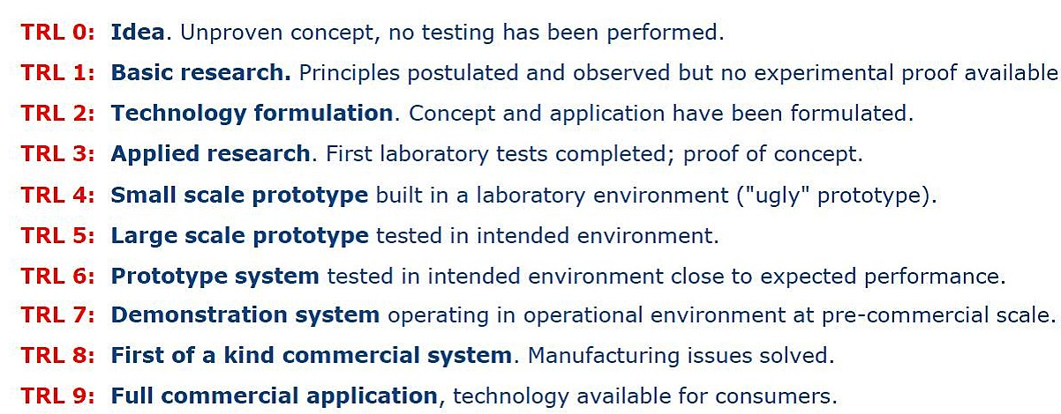

Conflict of interest:
Applicants are requested to read the Declaration of Interests policy (https://www.st-andrews.ac.uk/policy/research-external-work/declaration-of-interests-policy.pdf) and to declare any potential, real or perceived conflicts of interest with their proposed application.

Conditions of funding:
- Projects can start on or after 1st June 2022.
- Funded projects can run for a maximum of 10 months. Projects must finish by 31st March 2023.
- If there is any change to the expected timings or scope of the project, the staff member must contact the Impact Team as soon as possible.
- A record of any activities and impacts which result from the award must be entered in Pure. If there is no information related to the project in Pure when funding is awarded, the Impact Team will open a new impact record and add the application form.
- Pure should be populated by the researcher(s) involved with information on any events and evidence of impacts as the project progresses.
- Final project reports will be required upon completion of the project (the Impact Team will provide a proforma), and Pure entries must be up to date by the end of the grant and no later than 15 months after the funding start date.
- Participation at events to showcase the projects and outcomes may be requested.

Criteria for selection:
Essential:
- Clear and measurable milestones with a clear pathway to reach intended targets/objectives
- Clarity and realistic plans to generate change or benefit in the long term
- Clear and realistic plans for capturing evidence of activities and changes as they arise (See: REF2021 Annex A: https://impact.wp.st-andrews.ac.uk/files/2022/01/Annex-A-Impacts-and-Indicators.docx)
- Clearly and adequately addressed principles of responsible innovation (https://www.ukri.org/about-us/policies-standards-and-data/good-research-resource-hub/responsible-innovation/) and AREA (https://epsrc.ukri.org/index.cfm/research/framework/)
- Foundation of good quality research conducted, wholly or in part, at the University of St Andrews, which will link to any resulting impact
- Clarity on the planned or intended non-academic target audience(s) or partners
- Clear and realistic plans to engage with external partners, beneficiaries and stakeholders, where applicable
- Clear and realistic plans for capturing evidence of activities or impacts as they arise
- Appropriate levels of costing in support of the application

Desirable:
- High quality and/or innovative approach to engagement with users of research
- Delivering impact or translational activities across discipline boundaries through interdisciplinary means
- Long-term development of legacy/relationship building or a sustainable relationship with the wider community, external organisations, beneficiaries, or users of research
- Appropriate and effective Involvement of Eden Campus
- Alignment with the University Institutional Strategy’s ambition of being World-leading, Diverse, Global, and Entrepreneurial working within the context of Social Responsibility strategic objectives
- Contribution to strategic initiatives, e.g. STFC strategic themes, future REF case study, etc.

