University of St Andrews EPSRC Harmonised Impact Acceleration Account (IAA) 2022-23
Guidance Notes for Applicants
Impact Acceleration Accounts (IAAs) are strategic awards provided to research organisations to allow them to respond to impact opportunities in more flexible, responsive and creative ways. The awards are intended to add value to existing funding and take advantage of new or unforeseen opportunities to facilitate the realisation of impact. The funding can be used to support a wide range of activities that support the scheme aims, including engaging users, forging strategic partnerships or progressing commercial opportunities.
UKRI have removed the requirement that all IAA-funded projects be directly related to previous UKRI funding; however, they still require funded projects to sit within the remit and aims of the UKRI and for this funding opportunity, to sit predominantly within the remit and aims of the EPSRC. Therefore, any project supported by the EPSRC Harmonised IAA should be at least 50% within the EPSRC remit.

Background of harmonisation of IAAs
UKRI has brought together IAA funding from 5 participating councils (AHRC, BBSRC, EPSRC, MRC and the STFC) and harmonised Higher Education Institution (HEI) block applications for these as well as the award timelines and processes. Where applicable and appropriate, UKRI has encouraged research organisations to take advantage of the strategic opportunities afforded by the alignment of IAA awards across disciplines. However, it is recognised that opportunities for alignment may not always be obvious or accessible. Therefore, single discipline applications have not been disadvantaged.
UKRI IAA strategic aims are:
- to strengthen engagement with users to accelerate the translation of research outputs into impacts;
- to support, develop and foster strategic partnerships for knowledge exchange and impact, including across disciplines and sectors;
- to build and maintain an environment and culture which enables effective and ambitious knowledge exchange and impact, including the development of skills, capacity, and capability within research organisations;
- to provide early-stage support for progressing research outputs towards the next stages in the impact pipeline, for example, proof of concept projects, commercialisation, market validation, or activities targeting policy, business and the third sectors;
- to drive continuous improvement in impact by supporting innovation, enabling “fast failure”, and capturing learning through appropriate mechanisms; and
- to empower institutions with flexible and adaptive approaches to knowledge exchange and impact, including the ability to respond quickly to emerging opportunities.

St Andrews EPSRC Harmonised IAA
Please note there are two streams of funding for this call. The thresholds of funding for each of the two streams reflect the nature of the work to be undertaken. Please see the flow chart below.
Stream 1: Main Award (between £5k - £25k) – This stream is for projects with some proven partnerships in delivering impact, which in the past received some level of impact funding, whether internal, such from the KE&I or IIF, or external, such as previous IAA funding, and which are not at high risk of failure. These applications can be for up to 2 years of funding, i.e. up to £50k total, although the second year’s funding is dependent on positive Panel Review approval after year 1, at which point there will be the potential for an additional £10k top-up. We would expect that after 2 years of funding most projects in this stream will be in a position to seek other external funding opportunities.
Stream 2: Kick-start Award (up to £5k) – This stream is for exploratory projects which propose new partnerships, have little or no proven impact record and are defined as higher risk but also have a higher potential of reward for impact. These applications are for no more than 1 year of funding and are dependent on positive Panel Review approval after 6 months, at which point there will be the potential for an additional £2.5k top-up. It is recognised that successful awards could lead to subsequent proposals to the Main fund in future.
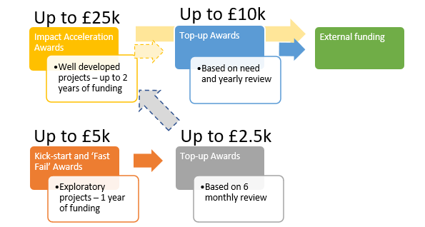
Eligibility criteria:
- The ESPRC Harmonised IAA fund is open to the University of St Andrews academic staff, including both research only and research & teaching staff on fixed or permanent contracts. We actively encourage applications from early career and under-represented researchers.
- Calls are open to all whose research falls within the EPSRC-remit.
- Interdisciplinary projects delivering impact or translational activities across discipline and faculty boundaries, i.e. across research council remit boundaries, are actively sought. Please note that such projects should be at least 50% within the EPSRC remit and should be submitted by the EPSRC remit academic.
- If there is a demonstrable urgent need, EPSRC Harmonised IAA rapid response or contingency applications can be submitted to Stream 2 (up to £5k) at any time.
- The Review Panel will have the authority, at their discretion, to redirect proposals to alternate streams.
- It is recognised that successful awards could lead to subsequent proposals to the fund in future.

Stream 1: Main Awards (between £5k - £25k)
Stream 1 includes up to £40k ring-fenced for applications from early career and under-represented researchers.
Stream 2: Kick-start Awards (up to £5k)
Stream 2 includes rapid response and contingency applications.

Deadline for proposals: 31 March 2022, 5pm
- Proposal applications (a) should be reviewed in advance with the relevant Director of Impact & Innovation (DOII), (b) must have the support of the relevant Schools/Departments, and (c) must be submitted with a specific (rather than general) statement of support from the submitting School/Department’s DOII.
- Innovation proposals should be discussed with the Technology Transfer Centre (TCC) team and must be submitted with a specific (rather than general) statement of support from TTC.
- Proposal applications will be assessed by an interdisciplinary Review Panel, made up of members of the EPSRC Harmonised IAA Steering Group.
- Decisions normally will be communicated within 2-3 weeks of the proposal deadlines.

The objective of this funding is to increase the impact of EPSRC-remit research by
- Strengthening non-academic user engagement
- Supporting Knowledge Exchange (KE) and commercialisation in the early stages by progressing research outputs/outcomes to the point where they would be supported by other funding
- Strengthening KE and commercialisation through culture and capability development
- Supporting activities that enable impact and innovation to be achieved in an effective and timely manner, including through secondments and people exchange
Funding will be targeted towards projects which create impact from EPSRC-remit research, and which enhance the institution’s impact and innovation, including for REF assessment exercises.
The Principal Investigator applying for EPSRC Harmonised IAA funding should be from an EPSRC-remit discipline or be conducting EPSRC-remit research. Projects must sit within the remit and aims of the UKRI and, for this funding opportunity, must sit predominantly within the remit and aims of the EPSRC. Therefore, any project supported by the EPSRC Harmonised IAA should be, at minimum, 50% within the EPSRC remit.
What can I apply for?
Eligible costs include any activities or mechanisms to achieve impact, such as:
- Travel and subsistence, consumables
- Researcher/PDRA salary
- Specialist advice and market research
- Meetings, workshops, conferences and networking events specifically targeted at external organisations and non-academic users of research.
- Provision of training or expertise which will benefit practitioners or other non-academics.
- Practical applications of research to improve the environment, reduce pollution, recycle waste products, or improve sustainability, health, quality of life, understanding of health issues, deliver new treatments or therapies, affect non-academic practice or guidelines, etc.
- Engagement with intermediary groups, such as NGOs, policymakers or local government which will influence subsequent policy and practice
Ineligible costs:
- Costs related to basic research activity, which should be funded through standard grant route
- Costs that should have been anticipated and supported as part of the initial funding (such as public engagement related to a specific grant)
- Undergraduate activities, core PhD, Masters and CPD costs or training
- Equipment with a value over £10,000 per item
- Indirect costs or estate costs
- Late-stage commercial development for which there are other funding sources, e.g. companies, Innovate UK, Venture Capital, Scottish Enterprise, etc.
Indicative staff costings
Awards will be made following approval by the committee and subject to FAS confirmation of costs (minor discrepancies are expected due to inflation and travel restrictions, for example).
For staff costs: please use the values below, which are based on a 1.0 FTE member of staff per month; please state the grade and number of months when including staff costs on your application.

Grade | Est. Total Annual Salary | Est. Total Monthly Salary
Grade 4 (e.g. Administrative Staff) | £32,539 | £2,712
Grade 5 (e.g. Technicians) | £38,954 | £3,246
Grade 6 (e.g. Research Assistant, Teaching Fellow) | £50,834 | £4,236
Grade 7 (e.g. replacement Lecturer) | £62,748 | £5,229

Impact types and indicators
As part of the application, impact types and associated indicators (KPIs) will need to be identified. These will be finalised, with input from the Review Panel, at the award stage. Please refer to the REF2021, Panel Criteria and Working Methods, Annex A (https://impact.wp.st-andrews.ac.uk/files/2022/01/Annex-A-Impacts-and-Indicators.docx).
Innovation projects
For commercialisation of research, we would expect to fund in Technology Readiness Levels (TRL) 3 to 6.
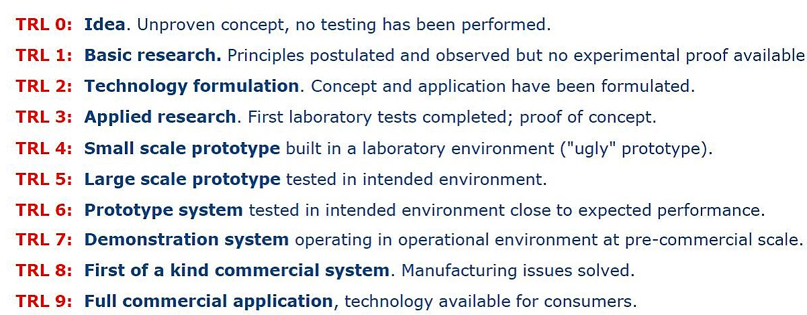

Conflict of interest:
Applicants are requested to read the Declaration of Interests policy (https://www.st-andrews.ac.uk/policy/research-external-work/declaration-of-interests-policy.pdf) and to declare any potential, real or perceived conflicts of interest with their proposed application.

Conditions of funding:
- For each project, PIs will attend a review (annually at minimum) with select panel members, key stakeholders (where appropriate) and relevant support unit representatives.
- Stream 1 (Main awards): Funded projects will typically last 1-2 years with the ability to top up if it is deemed beneficial to the project based on the outcomes of yearly reviews and reports to the Review Panel.
Stream 2 (Kick-start awards): will be for 1 year with the ability to top up if it is deemed beneficial to the project based on outcomes of 6 monthly reviews and reports to the Review Panel.
- If there is any change to the expected timings or scope of the project, the staff member must contact the Impact Team as soon as possible.
- A record of any activities and impacts which result from the award must be entered in Pure. If there is no information related to the project in Pure when funding is awarded, the Impact Team will open a new impact record and add the application form.
- Pure should be populated by the researcher(s) involved with information on any events and evidence of impacts as the project progresses.
- Final project reports will be required upon completion of the project (the Impact Team will provide a proforma), and Pure entries must be up to date by the end of the grant and no later than 15 months after the funding start date.
- Participation at events to showcase the projects and outcomes may be requested.

Criteria for selection:
Essential:
- Clear and measurable milestones with a clear pathway to reach intended targets/objectives
- Clarity and realistic plans to generate change or benefit in the long term
- Clear and realistic plans for capturing evidence of activities and changes as they arise (See: REF2021 Annex A: https://impact.wp.st-andrews.ac.uk/files/2022/01/Annex-A-Impacts-and-Indicators.docx)
- Clearly and adequately addressed principles of responsible innovation (https://www.ukri.org/about-us/policies-standards-and-data/good-research-resource-hub/responsible-innovation/) and AREA (https://epsrc.ukri.org/index.cfm/research/framework/)
- Foundation of good quality research conducted, wholly or in part, at the University of St Andrews, which will link to any resulting impact
- Clarity on the planned or intended non-academic target audience(s) or partners
- Clear and realistic plans to engage with external partners, beneficiaries and stakeholders, where applicable
- Clear and realistic plans for capturing evidence of activities or impacts as they arise
- Appropriate levels of costing in support of the application

Desirable:
- High quality and/or innovative approach to engagement with users of research
- Delivering impact or translational activities across discipline boundaries through interdisciplinary means
- Long-term development of legacy/relationship building or a sustainable relationship with the wider community, external organisations, beneficiaries, or users of research
- Appropriate and effective Involvement of Eden Campus
- Alignment with the University Institutional Strategy’s ambition of being World-leading, Diverse, Global, and Entrepreneurial working within the context of Social Responsibility strategic objectives
- Contribution to strategic initiatives, e.g. EPSRC strategic themes, future REF case study, etc.

