University of St Andrews Impact & Innovation Fund 2021/22
Guidance Notes for Applicants
The KE & Impact fund has been relaunched as the Impact and Innovation Fund. Impact funding requirements and eligibility remain the same as they were for the KE&IF. Innovation refers to funding for early-stage commercialisation. Please note there are different thresholds of funding for each of the two streams to reflect the nature of the work to be undertaken.

- The fund is open to the University of St Andrews academic staff.
- This funding will target projects which are based on research conducted (solely or jointly) at the University of St Andrews, and which also enhance the institution’s achieved impact, whether for future REF assessment exercises, or more generally.
- The funding will prioritise activities that would not be eligible or covered by follow-on grant funding, UKRI Impact Accelerator Accounts or other similar sources of funding.
- Calls are open to all disciplines as well as interdisciplinary projects and PhD internships (see below).
- If there is a demonstrable urgent need, Impact & Innovation Fund applications can be submitted at any time.
- It is recognised that successful awards could lead to subsequent proposals to the fund in future.
** This scheme will not fund research projects, internal salary time costs, activities where the main focus is academic, or the target audience is primarily academic. **

Main Impact & Innovation Fund Awards, including Impact PhD Internships
Deadlines for proposals: 8 November 2021 and 25 April 2022
Impact Main award: Suggested applications from £2,500 to £15,000
- Proposal applications (a) should be reviewed in advance with the School’s Director of Impact (DoI), (b) must have the support of the School/Department, and (c) must be submitted with a specific (rather than general) statement of support from the DOI.
- Proposal applications will be assessed by an interdisciplinary Review Group.
- Applications requesting over £15,000 in a single application will be considered, but success will depend on strategic priorities and the number of competing applications in the round.
- Decisions normally will be communicated within 2-3 weeks of the proposal deadlines.

Innovation Main award: Suggested applications from £7,500 to £30,000
- Proposal applications (a) should be reviewed in advance with the School’s Director of Impact (DoI) and the Technology Transfer Centre (TTC) team, (b) must have the support of the School/Department and the TTC team – a confirmation email to this effect must be email sent to impact@st-andrews.ac.uk, (c) must be submitted with a specific (rather than general) statement of support from the TTC team and (d) a confirmation email DOI.
- Proposal applications will be assessed by an interdisciplinary Review Group, which includes the Strategic Lead of Innovation at Eden Campus.
- Applications requesting over £30,000 in a single application will be considered, but success will depend on strategic priorities and the number of competing applications in the round.
- Decisions normally will be communicated within 2-3 weeks of the proposal deadlines.

Small Impact & Innovation Fund Awards
Impact Small award: Suggested applications from £500 to £2,500
Submissions will be clustered and considered for funding during the first weeks of November 2021, February 2022 and May 2022.
- Proposal applications (a) should be reviewed in advance with the School’s Director of Impact (DoI), (b) must have the support of the School/Department, and (c) must be submitted with a specific (rather than general) statement of support from the DOI.
- Proposal applications will be assessed by The VP Research & Innovation and the Research Impact Team. If it is deemed necessary due to conflict of interest or other factors, additional reviewers will be approached.
- If an immediate need is demonstrated, a Small fund application will be considered between reviewing time frames in an expedite manner.
- Applications will be considered on their individual merit using the criteria for selection (below). Please note that the same conditions of funding will apply.
- Decisions normally will be communicated within 2 weeks of the reviewing times.

Innovation Small award: Suggested applications from £500 to £7,500
- Proposal applications (a) should be reviewed in advance with the School’s Director of Impact (DoI) and the Technology Transfer Centre (TTC) team, (b) must have the support of the School/Department and the TTC team – a confirmation email to this effect must be email sent to impact@st-andrews.ac.uk, (c) must be submitted with a specific (rather than general) statement of support from the TTC team and (d) a confirmation email DOI.
- Proposal applications will be assessed by The VP Research & Innovation, and representatives from the Research Impact and the Technology Transfer Centre (TTC) teams. If it is deemed necessary due to conflict of interest or other factors, additional reviewers will be approached.
- If an immediate need is demonstrated, a Small fund application will be considered between reviewing time frames in an expedite manner.
- Applications will be considered on their individual merit using the criteria for selection (below). Please note that the same conditions of funding will apply.
- Decisions normally will be communicated within 2 weeks of the reviewing times.

What can I apply for?
- Travel costs can be included if they are part of the mechanisms to achieve impact, e.g. meetings with non-academic partners.
- The purchase of equipment is allowable if this is an essential part of the proposal to create impact.
Impact award
- Public engagement, which includes engagement with specific target audiences such as school children, will only be funded if it is an activity which is based on research conducted at the University of St Andrews, and could lead to demonstrable changes or benefits to the target audience(s).
NB: A plan for capturing evidence of impact is requested as part of the application.
- Activities which can be used to leverage support from other external sources are encouraged. External & internal matched funding, in cash or in-kind, should be sought where applicable. This includes any funding from the School or Department.
NB: It is recommended that other potential sources to support the application have been demonstrably explored.
- Flexible PhD internships for up to 3 months FTE with an external host organisation can be applied for at any time.

Covid-19 update: Regarding all such research that involves engagement of fieldworkers and working with collaborators [https://www.st-andrews.ac.uk/research/covid-19/]
If another person is undertaking work on a St Andrews researcher’s behalf it is important that:
- the activity is permissible, safe, ethical, and culturally appropriate
- the fieldworker or collaborator is not subjected to pressure or coercion from those in St Andrews to undertake this work, or assume risks, such as through threat of financial or other disadvantage
- the relationship between the St Andrews researcher and the fieldworker or collaborator must be in line with pre-COVID norms as appropriate to the situation. For example, paying individuals to collect certain types of data might be an established pre-COVID norm in some situations, but where participatory collaboration is the norm this may be unethical.
Innovation award
- Strengthen user engagement
- Strengthen the exchange of knowledge through culture change and capability development, including through the development of skills for KE activity
- Support knowledge exchange and commercialisation at early stages of progressing research outputs and outcomes to the point when they would be supported by other funding
- Support new, innovative and imaginative approaches to KE and Impact, including processes that enable “fast failure” and appropriate learning
- Support activities that enable impact to be achieved in an effective and timely manner including secondments and people exchange
- For commercialisation of research, we would expect to fund in Technology Readiness Levels (TRL) 3 to 6.
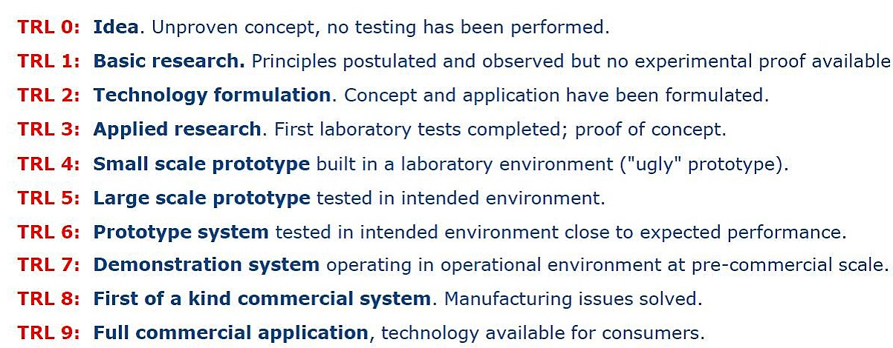

Types of projects which could be funded:
This is not a prescriptive list of project types and any research-based projects which are aimed at the creation of impact (positive non-academic change or benefit) will be considered.
Impact award
- Events, exhibits, websites which engage the general public with research-based knowledge and improve understanding.
- Workshops, conferences and networking events specifically targeted at external organisations and non-academic users of research.
- Provision of training or expertise which will benefit practitioners or other non-academics.
- Practical applications of research to improve the environment, reduce pollution, recycle waste products, or improve sustainability, health, quality of life, understanding of health issues, deliver new treatments or therapies, affect non-academic practice or guidelines, etc.
- Engagement with intermediary groups, such as NGOs, policy makers or local government which will influence subsequent policy and practice.
- PhD internships (arrangements can be flexible and are expected to total 1 to 3 months FTE) to work with an organisation in the private, public or third sector.

Innovation award
- Strategic engagements with industry/business/SMEs or other external organisations.
- Early-stage commercialisation, proof of concept, development of prototypes, market research, etc.

PhD internships should be organised with the organisation separately and are intended for relationship building with the University. They will be paid pro-rata at the UKRI stipendiary rate (£15,609 for academic year 2021/22), which is £3,902.25 for the equivalent of 3 months FTE. UKRI-funded researchers will continue to be in receipt of their PhD stipend and their stipendiary period will be extended in line with the placement duration.
PhD Internship application process
Applications for internships which promote new collaborations will be prioritised for funding.
- Stage 1: As an Expression of Interest, please complete and submit the “University of St Andrews Impact & Innovation Fund 2021/22” application. We suggest that preliminary negotiations with relevant parties start before this application is submitted.
- Stage 2: If the Stage 1 funding is approved in principle, a completed “University of St Andrews Impact & Innovation Fund PhD Internship” form will need to be submitted within 4 weeks of successful Stage 1 email notification. This PhD Internship form scopes the project in more detail to provide clear objectives, expectations and structure to the proposed work to ensure that the internships are successful for all parties. It will require the signatures of the doctoral student, their supervisor and the host organisation mentor. Please request this form by emailing impact@st-andrews.ac.uk.
- Stage 3: Upon Stage 2 approval of the internship project, a “University of St Andrews PhD Internship Placement Agreement” must be signed by the doctoral student, their supervisor, the host organisation mentor and the VP Research & Innovation. This document is a legal document aimed primarily to ensure the safety of the student.
Please request this form by emailing impact@st-andrews.ac.uk.
NB: Students must comply with the University UKBA attendance monitoring policy (Tier 4 visa holders).
Please contact impact@st-andrews.ac.uk if you are interested in pursuing a PhD internship.

Conditions of funding:
- Funded projects will typically last 1-12 months. The grant spend must be completed within 15 months of the funding decision. If there is any change to the expected timings or scope of the project, the staff member must contact the Impact Team as soon as possible.
- A record of any activities and impacts which result from the award must be entered in Pure. If there is no information related to the project in Pure when funding is awarded, the Impact Team will open a new impact entry and add the application form.
- Pure should be populated by the researcher(s) involved with information on any events and evidence of impacts as the project progresses.
- Final project reports will be required upon completion of the project (the Impact Team will provide a proforma) and Pure entries must be up to date by the end of the grant and no later than 15 months after the funding start date.
- Participation at an annual event to showcase the projects and outcomes may be requested.

Criteria for selection:
Essential:
- Foundation of good quality research conducted, wholly or in part, at the University of St Andrews which will link to any resulting impact. For PhD internships, this may be linked to the School/Dept. or supervisor’s work.
- Clarity on the planned or intended non-academic target audience(s) or partners
- Clear and realistic plans to engage with external partners/audiences
- Clear and realistic plans for capturing evidence of activities or impacts as they arise
- Appropriate levels of costing, provided by FAS where appropriate, in support of the application
Desirable:
- External & internal matched funding, in cash or in-kind, including any funding from the School or Department
- High quality and/or innovative approach to engagement with wider community, external organisations, beneficiaries, or users of research
- Long-term development of legacy/relationship building or a sustainable relationship with the wider community, external organisations, beneficiaries, or users of research
- Opportunity to gain additional funding from external partners
- Raise profile of University of St Andrews in wider community
- Contribute to strategic initiatives, e.g. REF2021, etc.

