University of St Andrews - EPSRC Impact Acceleration Account 2021-2022

Guidance Notes for Applicants

- For 2021-2022, the fund will be split into 2 pots: Small fund & Main fund

Small Fund IAA Awards:
Applications for Small Award can be up to £7,500

If an immediate need is demonstrated, a Small fund application will be considered at any point but please note that they are held to completion deadlines.

Main Fund IAA Awards:
Applications for Main Award can be from £7,500 to £30,000

- The objective of this funding is to increase the impact of EPSRC funded research by
- Strengthening non-academic user engagement
- Strengthening the exchange of knowledge through culture and capability development
- Supporting Knowledge Exchange (KE) and commercialisation in the early stages, by progressing research outputs/outcomes to the point where they would be supported by other funding
- Supporting activities that enable impact to be achieved in an effective and timely manner including secondments and people exchange

- IAA funding will be targeted towards projects which create impact from the EPSRC portfolio and EPSRC funded research, meet intended outcomes (see 1 above) and which enhance the institution’s achieved impact, including REF assessment exercises.

- Underpinning research from the EPSRC portfolio includes work funded by EPSRC grants, PhD projects supported by EPSRC CDTs/DTPs and EPSRC Fellowships. Previous EPSRC IAA funding alone is not acceptable as the ‘underpinning research’. There is no time limit on when the underpinning research was carried out, or restrictions on where it was carried out.

- This fund is open to the University of St Andrews academic staff, including both research only and research & teaching staff on fixed or permanent contracts.

- The person applying for IAA funding does not have to be the PI on the underpinning research, e.g. a social or environmental scientist could receive EPSRC IAA funding and run a project that would appear to be outside the EPSRC remit, as long as the work built upon EPSRC research.

- External funding support for the project, in cash or in-kind, should be sought where applicable.

- Where the project is commercialisation of research, we would expect to fund in Technology Readiness Levels (TRL) 3 to 6. We would expect researchers to contact the Technology Transfer Centre to discuss funding for projects already at TRL 7 or above.
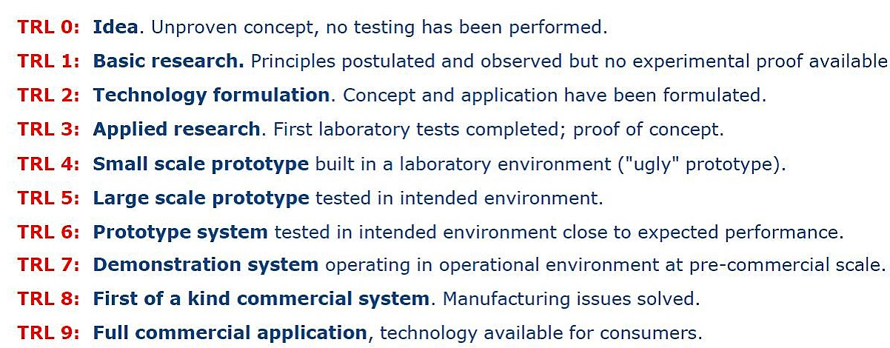

- The types of project which could be funded include:
Project Development – early stages
- Proof of concept, prototype development
- Exploratory meetings or collaborations with industry and clinical partners
- Travel, meetings and attendance at events to facilitate new partnerships
Project Development – later stages
- Market assessments and market research
- Support for late stage demonstrator development, field trials, (TRL 7) where no commercial or other funding source available
- Prototype design and testing
- Continuation of successful projects which have been funded in earlier rounds of IAA funding to maximise their return on investment to date
- Work to support technology or patent licensing, and commercialisation through spin-out company formation (supported by Technology Transfer Centre)

Researcher Development:
- Post-doctoral impact placements, e.g. for the continuation of previous placement/industry-related project at PhD level
- People exchange and secondments into/from industry or another organisation
- Supporting attendance at exhibitions, seminars, CPD and short courses

Please note any secondments into a commercial or other organisation must be supported with a letter from that organisation outlining the support/facilities provided and other opportunities which will be open to the researcher.

Other project types not covered by the above descriptors
We will take a flexible approach to allocating funding to projects which use innovative methods to achieve impact from EPSRC funded research, which may include influence on policy or public understanding.

- Eligible costs include any activities or mechanisms to achieve impact from EPSRC funded research, including:
- Travel and subsistence, consumables
- Researcher/PDRA salary
- Meetings, networking with non-academic partners
- Specialist advice, market research
- Ineligible costs:
- Costs related to basic research activity, which should be funded through standard grant route
- Costs which should have been anticipated and supported through Pathways to Impact (such as public engagement related to a specific grant)
- Undergraduate activities, core PhD training, Masters and CPD
- Equipment with a value over £10,000
- Academic staff time (with exception of secondments)
- Indirect costs or estate costs
- Late stage commercial development for which there are other funding sources e.g. companies, Innovate UK, Venture Capital, Scottish Enterprise
- All spend on the overall grant must be completed by 31st March 2022 with no option of extension.
- A condition of funding is that an impact narrative is completed in the PURE profile of all PIs. The Research Impact Team will open a new impact case study in Pure for each funded project and attach application and report forms. Pure should be populated with information on any events and impacts, as the project progresses, by the PIs. PURE entries must be up to date by 30th June 2022.
- Interim reports will be required to coincide with the EPSRC’s requirement for any interim or annual reports from the University of St Andrews, and standard report forms will be provided by Research Impact when required.
- Criteria for selection:
Essential:
- Clear and measurable milestones with clear pathway to reach intended targets/objectives
- Clarity and realistic plans to generate change or benefit in the long term
- Clear and realistic plans for capturing evidence of activities and changes as they arise
- Clearly and adequately address the principles of responsible innovation and AREA (see https://epsrc.ukri.org/index.cfm/research/framework/)
- Appropriate levels of costing, provided by FAS where appropriate, in support of the application

Desirable:
- External & internal matched funding, in cash or in-kind
- High quality and/or innovative approach to engagement with wider community, external organisations, beneficiaries or users of research
- Long-term development of legacy/relationship building or a sustainable relationship with the wider community, external organisations, beneficiaries or users of research
- Opportunity to gain additional funding from external partners
- Raise profile of University of St Andrews in wider community
- Contribute to the University’s strategic objectives

- The deadline for submissions is Noon 25th May 2021.

