University of St Andrews - EPSRC Impact Acceleration Account 2017/18

Guidance Notes for Applicants

- The objective of this funding is to increase the impact of EPSRC funded research by
- Strengthening non-academic user engagement
- Strengthening the exchange of knowledge through culture and capability development
- Supporting Knowledge Exchange (KE) and commercialisation in the early stages, by progressing research outputs/outcomes to the point where they would be supported by other funding
- Supporting activities that enable impact to be achieved in an effective and timely manner including secondments and people exchange

- IAA funding will be targeted towards projects which create impact from the EPSRC portfolio and EPSRC funded research, meet intended outcomes (see 1 above) and which enhance the institution’s achieved impact, including REF assessment exercises.

- Underpinning research from the EPSRC portfolio includes work funded by EPSRC grants, PhD projects supported by EPSRC CDTs/DTPs and EPSRC Fellowships. Previous EPSRC IAA funding alone is not acceptable as the ‘underpinning research’. There is no time limit on when the underpinning research was carried out, or restrictions on where it was carried out.

- The person applying for IAA funding does not have to be the PI on the underpinning research, e.g. a social or environmental scientist could receive EPSRC IAA funding and run a project that would appear to be outside the EPSRC remit, as long as the work built upon EPSRC research.

- External funding support for the project, in cash or in-kind, should be sought where applicable.

- Where the project is commercialisation of research, we would expect to fund in Technology Readiness Levels (TRL) 3 to 6. We would expect researchers to contact the Knowledge Transfer Centre to discuss funding for projects already at TRL 7 or above
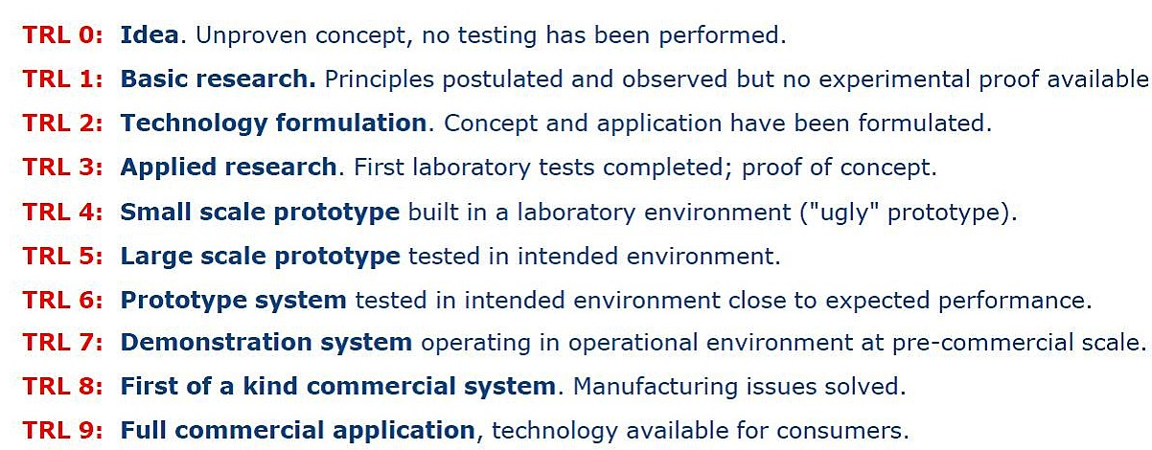

- The types of project which could be funded include:
Project Development – early stages
- Proof of concept, prototype development
- Exploratory meetings or collaborations with industry and clinical partners
- Travel, meetings and attendance at events to facilitate new partnerships
Project Development – later stages
- Market assessments and market research
- Support for late stage demonstrator development, field trials, (TRL 7) where no commercial or other funding source available
- Prototype design and testing
- Continuation of successful projects which have been funded in earlier rounds of IAA funding to maximise their return on investment to date
- Work to support technology or patent licensing, and commercialisation through spin-out company formation (supported by Knowledge Transfer Centre)

Researcher Development:
- Post-doctoral impact placements, e.g. for the continuation of previous placement/industry-related project at PhD level
- People exchange and secondments into/from industry or other organisation
- Supporting attendance at exhibitions, seminars, CPD and short courses

Please note any secondments into a commercial or other organisation must be supported with a letter from that organisation outlining the support/facilities provided and other opportunities which will be open to the researcher.

Other project types not covered by the above descriptors
We will take a flexible approach to allocating funding to projects which use innovative methods to achieve impact from EPSRC funded research, which may include influence on policy or public understanding (see point 4 in these Guidance Notes).

- Eligible costs include any activities or mechanisms to achieve impact from EPSRC funded research, including:
- Travel and subsistence, consumables
- Researcher/PDRA salary
- Meetings, networking with non academic partners
- Specialist advice, market research
- Ineligible costs:
- Costs related to basic research activity, which should be funded through standard grant route
- Costs which should have been anticipated and supported through Pathways to Impact (such as public engagement related to a specific grant)
- Undergraduate activities, core PhD training, Masters and CPD
- Equipment with a value over £10,000
- Academic staff time (with exception of secondments)
- Indirect costs or estate costs
- Late stage commercial development for which there are other funding sources e.g. companies, Innovate UK, Venture Capital, Scottish Enterprise
- All spend on the overall grant must be completed by 31st March 2020 with no option of extension.
- A condition of funding is that an impact narrative is completed in the PURE profile of all PIs. Research Policy Office (RPO) staff will open a new impact case study in Pure for each funded project, and attach application and report forms. Pure should be populated with information on any events and impacts, as the project progresses, by the PIs. PURE entries must be up to date by 31st June 2020.
- Interim reports will be required to coincide with the EPSRC’s requirement for any interim or annual reports from the University of St Andrews, and standard report forms will be provided by RPO when required.

EPSRC IAA 2017-18 University of St Andrews Application Form
Title of project
Principal investigator(s) /project lead(s) for this proposal
School/Department
Main applicant - Contact Email
Type of project i.e.
Early Stage/Late Stage/Researcher Development or Other (e.g. policy/public understanding)
Technology Readiness Level
Total funding requested from EPSRC IAA - please use FAS for accurate costings including any salaries.
Start date
Duration of project
Any other funding obtained? (e.g. grant support, cash or in-kind contributions)
Please give amount and source.
Brief description of any EPSRC-funded research which underpins this project proposal. Give PI name, grant title(s) and code(s) if available.
Suggested max 300 words
Previous IAA funding alone is not eligible as underpinning research.
General outline of project with planned dates for some key measurable milestones in pathway to reach intended targets/objectives
e.g. networking events, industry visits, internships, secondment, PoC, patent application.
Suggested max 500 words
Area(s) of intended impact (e.g. health, economy, environmental, public understanding) - describe intended changes or benefits in the longer term.
Suggested max 300 words
Industry Sector related to area of intended impact. Please select from drop down of Researchfish sectors. | Choose an item.
Intended beneficiaries – briefly describe which group or individuals (outside academia) will potentially benefit in the longer term.
Suggested max 200 words
Current non-academic collaborators (in relation to this proposal). Give name and organisation if applicable.
Any other academic collaborators and institution – including other HEIs if applicable
Describe how you plan to collect evidence of impact when it occurs (using quantitative or qualitative indicators).
Any other relevant information on your project, such as fit with institutional priorities, EPSRC strategic themes, Global Challenges, REF 2021 potential case study etc.
Suggested max 100 words

